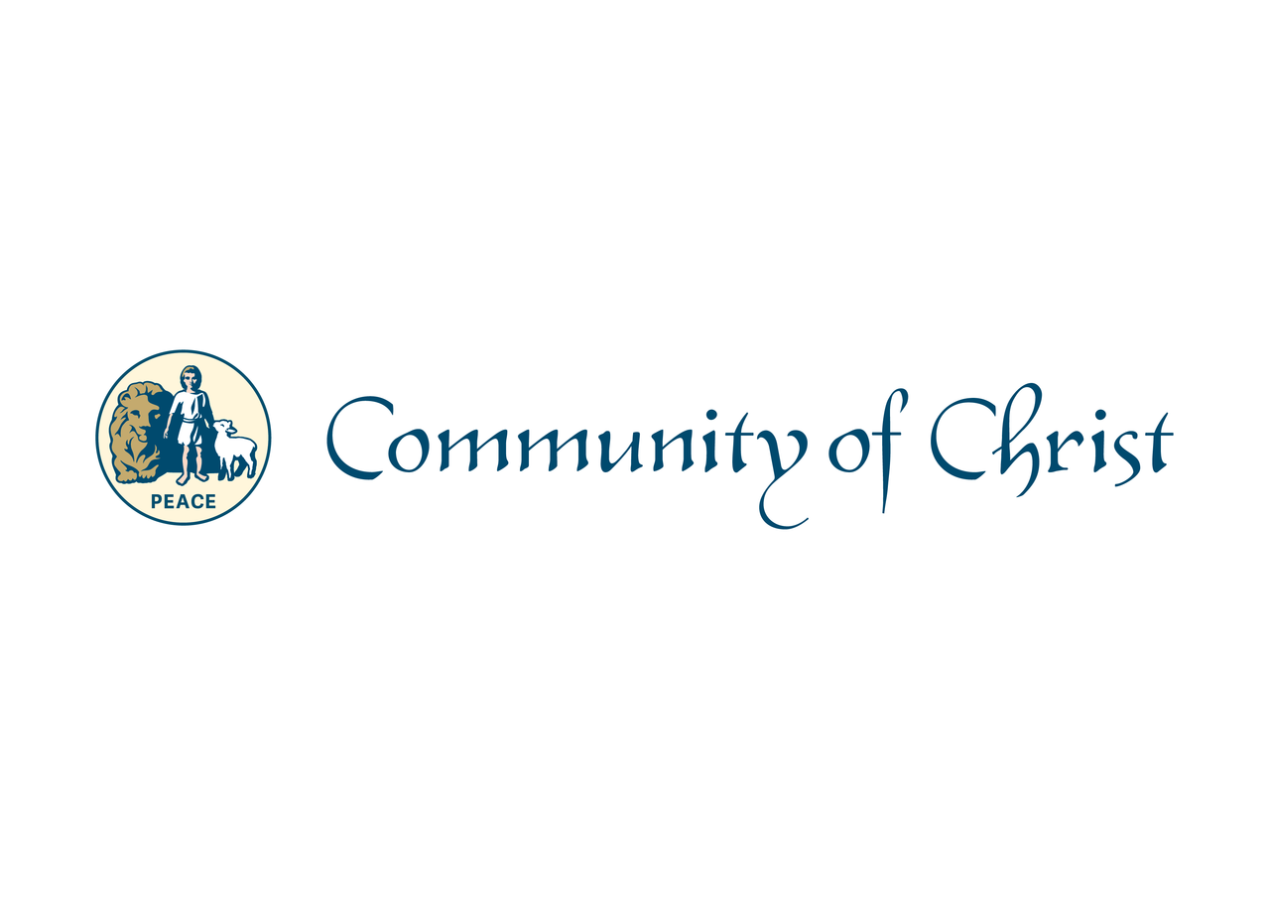

Oklahoma Mission Center Conference 2017

Schedule

9:00 – 9:30 – Worship - Julie Lacy

9:45 - 10:45 - Area updates

10:45 - Break

11:00 - Linda Booth

11:30 -12:30 - Lunch

12:30 Budget overview - Mike Wellington

1:00 - MC direction - Carl Edgerton–

1:30 - Business Meeting

3:30 – Ice Cream Social
Reception for Chuck and Marilyn Woodstock

